**Project Name:** ${projectName}

**Location:** From ${locationFrom} To ${locationTo}

**Performed by:** ${performedBy} **Test Date:** ${inspectDate}

**Test Type:** ${testType}

[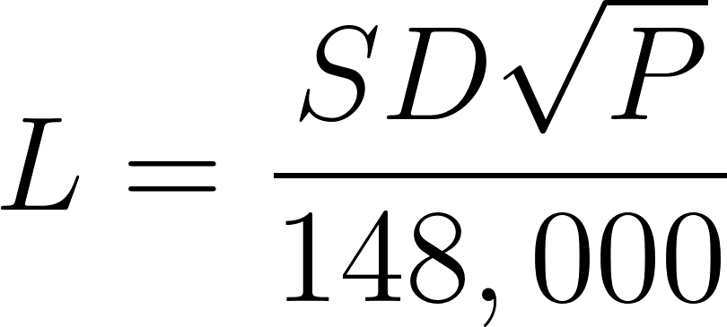](https://www.codecogs.com/eqnedit.php?latex=L%20%3D%20%5Cfrac%7BSD%5Csqrt%7BP%7D%7D%7B148%2C000%7D#0)

*L = Quantity of makeup water / Testing leak allowance (gal/hr)*

*S = Length of pipe section being tested (ft)*

*D = Nominal diameter of pipe (in)*

*P = Average test pressure during the hydrostatic test (psi)*

S = ${sValue}ft D = ${dValue}in P = ${pValue}psi

**Start Time:** ${startTime} => **Pressure:** ${pValueStart} psi

**End Time:** ${endTime} => **Pressure:** ${pValueEnd} psi

**Total Pressure Loss:** ${pValueLoss} psi

L = ${lValue} (gal / hr)

**Observed by:** ${inspectorName}

**Test Results & Comments:** ${testResult}

${testComments}

**Reviewed by EOR:** ______________________ **Date:** ____________